Threat Intelligence Enrichment Report

Analyst: Idris Ibrahim Adetola
Date: 13-12-2025
Alert Source: Phishing Email Investigation
Related Case: Day 11 - Alert Triage

Indicator Analyzed (IOC)

- IP Address (Command & Control)

Value : 37.120.233.226
Verdict: malicious
Summary: Identified as active Command and Control Infrastructure, associated with remote access trojan activity.
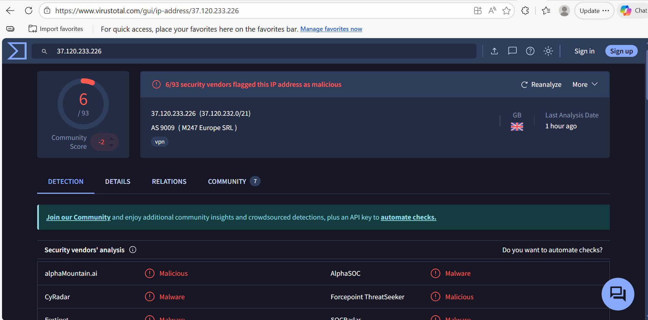
Figure 1 - VirusTotal detection results for IP address

- URL (Phishing Link)

Value: https://files-ld.s3.us-east-2.amazonaws.com/59cbd215-76ea-434d-93ca-4d6aec3bac98-free-coffee.zip
Verdict: malicious
Summary: Identified as a phishing link and malware payload delivering vector, used to deliver a compressed malicious file.
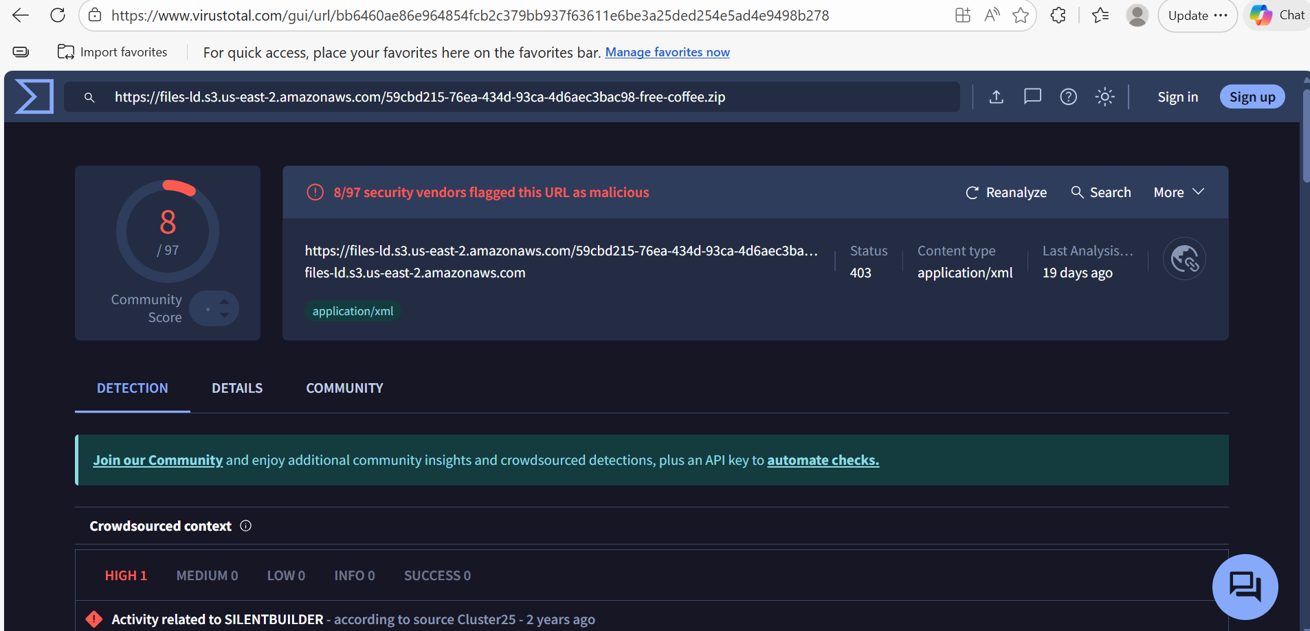
Figure 2 - VirusTotal detection results for URL

- File Hash (SHA - 256 )

Value:CD903AD2211CF7D166646D75E57FB866000F4A3B870B5EC759929BE2FD81D334
Verdict: Malicious
Summary: flagged by multiple threat intelligence vendors as a Trojan associated with AsyncRAT.

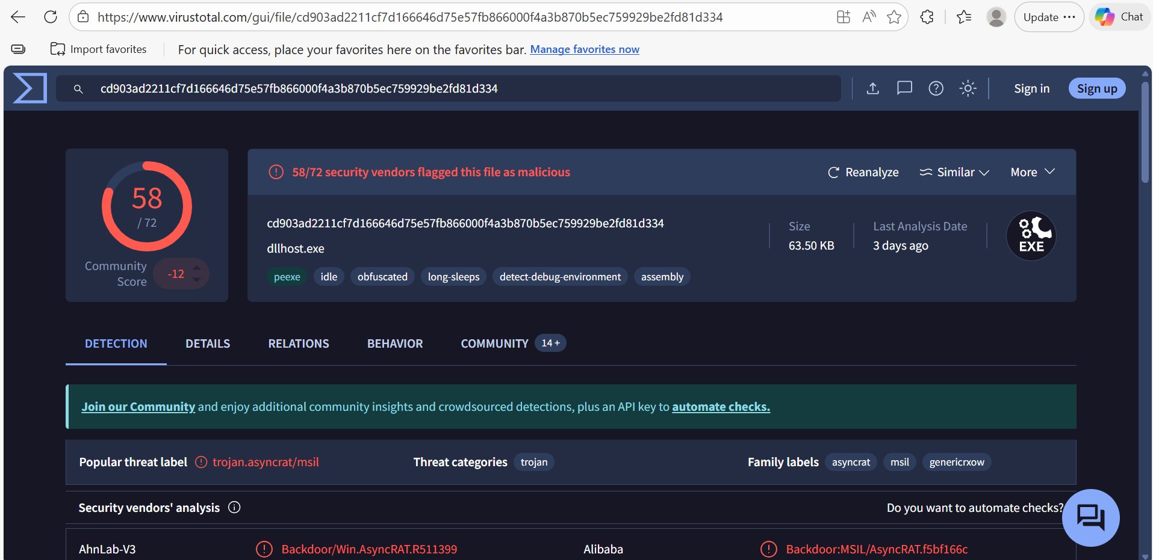
Figure 3 - VirusTotal detection results for SHA-256 hash

Investigation Context
The IOCs were obtained during a phishing email investigation after detecting outbound communication from the affected endpoint, indicating possible post compromise command-and-control activities.

Tools Used For Enrichment
- VirusTotal
- AbuseIPDB
- AlienVault OTX
- GreyNoise (Basic)

Correlation & Analysis

The analyzed IP address, URL and File Hash were all linked to the same phishing investigation. Threat Intelligence correlation confirms the IOCs were part of coordinated attack chain involving phishing-based delivery followed by post compromised command-and-control communication.

Final Risk Assessment
- Reputation: malicious
- Threat Type: C2 / Remote Access Trojan (RAT)
- Likelihood: High
- Impact: High
- Overall Risk level : High - Confirmed malicious Phishing Campaign with endpoint compromise
- Confidence Level: HIgh - Multiple threats intelligence sources confirmed malicious classifications

Recommended Action
- Block IP address at Firewall and EDR
- Isolate affected endpoint
- Perform endpoint malware cleanup
- User awareness and phishing retraining
- Escalate incident to Tier 2 - SOC for further investigation.

